Session 2025-2026(EVEN)

Vision: To build innovative technology solutions that improve public safety, healthcare, and smart ecosystems, creating a positive impact on society through software and IoT. | Mission: To continuously develop strong skills in software engineering, IoT, AI, and cloud technologies, apply them to real-world problems, and deliver scalable, user-centric solutions through learning, innovation, and collaboration.

Program Educational Objectives of the program (PEO): (broad statements that describe the professional and career accomplishments)
PEO1 | Preparation | P: Preparation | Pep-CL abbreviation  pronounce as Pep-si-lL easy to recall
PEO2 | Core Competence | E: Environment (Learning Environment)
PEO3 | Breadth | P: Professionalism
PEO4 | Professionalism | C: Core Competence
PEO5 | Learning Environment | L: Breadth (Learning in diverse areas)

Program Outcomes (PO): (statements that describe what a student should be able to do and know by the end of a program)
Keywords of POs:
Engineering knowledge, Problem analysis, Design/development of solutions, Conduct Investigations of Complex Problems, Engineering Tool Usage, The Engineer and The World, Ethics, Individual and Collaborative Team work, Communication, Project Management and Finance, Life-Long Learning

PSO Keywords: Cutting edge technologies, Research

“I am an engineer, and I know how to apply engineering knowledge to investigate, analyse and design solutions to complex problems using tools for entire world following all ethics in a collaborative way with proper management skills throughout my life.” to contribute to the development of cutting-edge technologies and Research.

Integrity: I will adhere to the Laboratory Code of Conduct and ethics in its entirety.

Dhanashri Raut

Name and Signature of Student and Date
(Signature and Date in Handwritten)

Session | 2024-25 (EVEN) |  | Course Name | Mobile and Web Application for IOT Lab
Semester | 6 |  | Course Code | 23IOT1624
Roll No | 05 |  | Name of Student | Dhanashri raut
Practical Number |  | 5
Course Outcome |  | - Understand and apply basic Kotlin programming constructs including variables, control structures, functions, null safety, and object-oriented concepts for Android app development.  - Design and develop responsive user interfaces using XML layout files, ViewGroups, and widgets in Android Studio, adhering to Material Design principles.  - Implement event handling and application logic using Kotlin to capture user input, manage app state, navigate between screens, and interact with Android system components like Toasts and Dialogs  - Integrate learned concepts to develop a mini Android application that demonstrates use of ViewModel, multi-screen navigation, and proper UI/UX design for real-world problem-solving
Aim |  | Objective: Design UI using XML layouts and widgets. Tasks: LinearLayout,  RelativeLayout, ConstraintLayout, TextView, EditText, Button.
Problem Definition |  | Managing student information manually is time-consuming and prone to errors. Educational institutions need a simple, efficient, and user-friendly digital solution to input, store, and manage student details such as roll number, name, department, year, email, and phone number.
Theory  (100 words) |  | Android user interfaces are designed using layouts and widgets. Layouts define the structure and positioning of UI elements on the screen, while widgets are the interactive components such as buttons and text fields.  - LinearLayout arranges child views either vertically or horizontally in a single direction.  - RelativeLayout positions child views relative to each other or to the parent container.  - ConstraintLayout provides a flexible and efficient way to create complex layouts by defining constraints between views and their parent or sibling views.  Common widgets:  - TextView: Displays text to the user.  - EditText: Allows user input.  - Button: Triggers actions when clicked.  Using these layouts and widgets properly ensures a responsive and user-friendly interface across different device sizes.
Procedure and Execution  (100 Words) |  | Step 1: Create a new Android Project  - Open Android Studio → New Project → Empty Activity → Enter project details → Finish.  Step 2: Design UI using LinearLayout  - Open activity_main.xml.  - Replace root layout with <LinearLayout> and set orientation to vertical or horizontal.  - Add TextView, EditText, and Button inside LinearLayout with proper attributes.  Step 3: Design UI using RelativeLayout  - Replace root layout with <RelativeLayout>.  - Position widgets using layout_alignParentTop, layout_below, layout_toRightOf attributes.  - Add TextView, EditText, and Button with relative positioning.  Step 4: Design UI using ConstraintLayout  - Replace root layout with <ConstraintLayout>.  - Add widgets and apply constraints like layout_constraintTop_toTopOf, layout_constraintStart_toStartOf etc.  - Align views properly for responsive layout.  Step 5: Run and test the UI designs on emulator/device.
Code:
<androidx.constraintlayout.widget.ConstraintLayout
xmlns:android="http://schemas.android.com/apk/res/android"
xmlns:app="http://schemas.android.com/apk/res-auto"
android:layout_width="match_parent"
android:layout_height="match_parent"
android:padding="16dp">
<TextView
android:id="@+id/tvTitle"
android:layout_width="wrap_content"
android:layout_height="wrap_content"
android:text="Student Information Form"
android:textSize="22sp"
android:textStyle="bold"
app:layout_constraintTop_toTopOf="parent"
app:layout_constraintStart_toStartOf="parent"
app:layout_constraintEnd_toEndOf="parent"
android:layout_marginTop="16dp"/>
<EditText
android:id="@+id/etRollNo"
android:layout_width="0dp"
android:layout_height="wrap_content"
android:hint="Roll Number"
android:inputType="number"
app:layout_constraintTop_toBottomOf="@id/tvTitle"
app:layout_constraintStart_toStartOf="parent"
app:layout_constraintEnd_toEndOf="parent"
android:layout_marginTop="20dp"
<EditText
android:id="@+id/etName"
android:layout_width="0dp"
android:layout_height="wrap_content"
android:hint="Student Name"
android:inputType="textPersonName"
app:layout_constraintTop_toBottomOf="@id/etRollNo"
app:layout_constraintStart_toStartOf="parent"
app:layout_constraintEnd_toEndOf="parent"
android:layout_marginTop="12dp"/>
<EditText
android:id="@+id/etDepartment"
android:layout_width="0dp"
android:layout_height="wrap_content"
android:hint="Department"
android:inputType="text"
app:layout_constraintTop_toBottomOf="@id/etName"
app:layout_constraintStart_toStartOf="parent"
app:layout_constraintEnd_toEndOf="parent"
android:layout_marginTop="12dp"/><EditText
android:id="@+id/etYear"
android:layout_width="0dp"
android:layout_height="wrap_content"
android:hint="Year (e.g., 2nd Year)"
android:inputType="text"
app:layout_constraintTop_toBottomOf="@id/etDepartment"
app:layout_constraintStart_toStartOf="parent"
app:layout_constraintEnd_toEndOf="parent"
android:layout_marginTop="12dp"/><EditText
android:id="@+id/etEmail"
android:layout_width="0dp"
android:layout_height="wrap_content"
android:hint="Email ID"
android:inputType="textEmailAddress"
app:layout_constraintTop_toBottomOf="@id/etYear"
app:layout_constraintStart_toStartOf="parent"
app:layout_constraintEnd_toEndOf="parent"
android:layout_marginTop="12dp"/><EditText
android:id="@+id/etPhone"
android:layout_width="0dp"
android:layout_height="wrap_content"
android:hint="Phone Number"
android:inputType="phone"
app:layout_constraintTop_toBottomOf="@id/etEmail"
app:layout_constraintStart_toStartOf="parent"
app:layout_constraintEnd_toEndOf="parent"
android:layout_marginTop="12dp"/><Button
android:id="@+id/btnSubmit"
android:layout_width="wrap_content"
android:layout_height="wrap_content"
android:text="Submit"
app:layout_constraintTop_toBottomOf="@id/etPhone"
app:layout_constraintStart_toStartOf="parent"
app:layout_constraintEnd_toEndOf="parent"
android:layout_marginTop="20dp"/>
</androidx.constraintlayout.widget.ConstraintLayout>

Output:

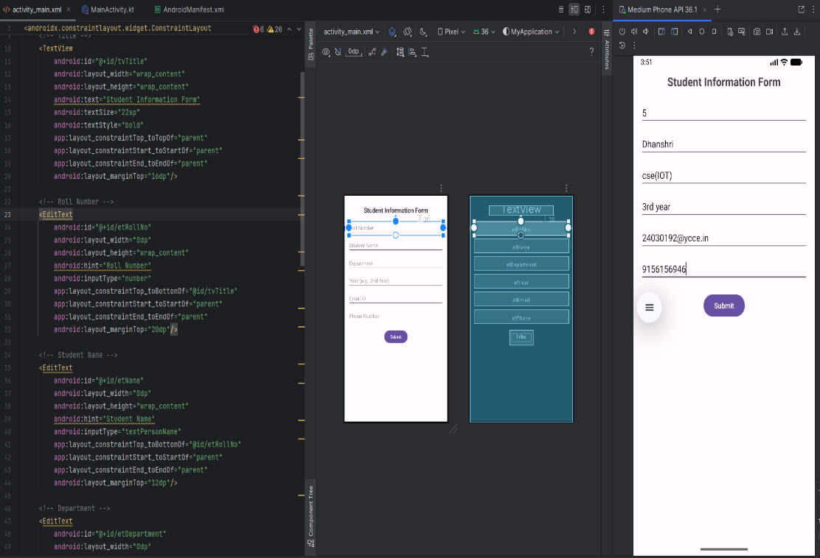

Output Analysis |  | • LinearLayout is simple but less flexible for complex UI.  • RelativeLayout offers better control for positioning but can become complex with many views.  • ConstraintLayout is powerful and recommended for modern UI designs due to flexibility and performance.  • Proper use of TextView, EditText, and Button ensures interactive UI.
Link of student Github profile where lab assignment has been uploaded |  | https://github.com/24030192-lab/PE-
Conclusion |  | The experiment helped understand different layout managers and their usage for designing Android user interfaces. ConstraintLayout was found to be the most versatile and efficient. Mastery of these layouts and widgets is crucial for creating responsive and user-friendly Android applications.
Plag Report (Similarity index < 12%) |  | 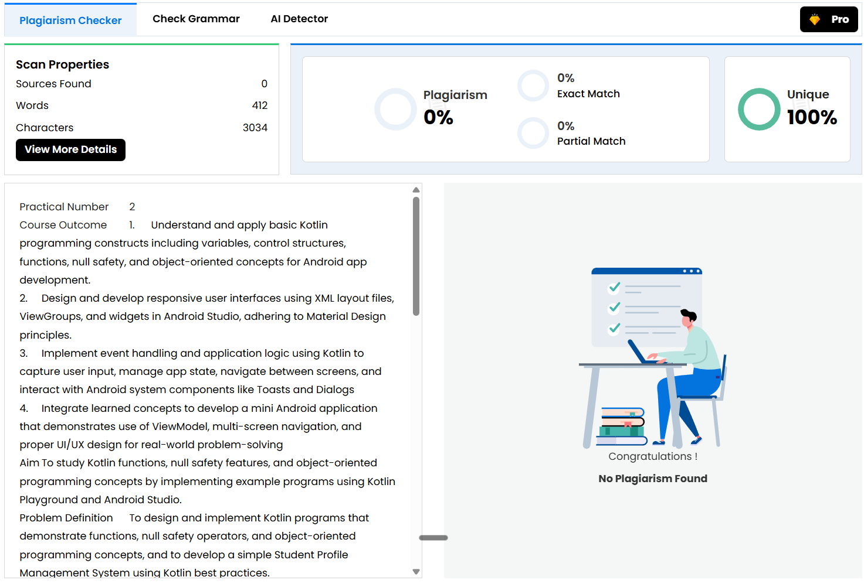
Date |  | 06/02/2026

